EMS & Central Data Service (Payer) Design Document

* BatchService
  1. Configuration File to control file to process and call producerService accordingly
* ProducerService

1. Batch service calls the REST end point to send the message. (decide to not use tool name, kakfa etc., in the implementation since it can be changed)
   1. Endpoint : <http://localhost:8085/mckesson>

                                                              i.      Where APPLICATIONNAME Can be

* + - 1. DRGPAYER
      2. DRGPLAN
      3. NCPDP
      4. ANYNAME_DEPENDING_ON_THE_SERVICE _*THAT_WHAT*_TO_USE_MECKESSON_MESSAGING_SERVICE
    1. Sample END Points for BatchService (one endpoint, since the type will be passing as parameter)
       1. http://localhost:8085/mckesson

                                                          iii.      Sample json message

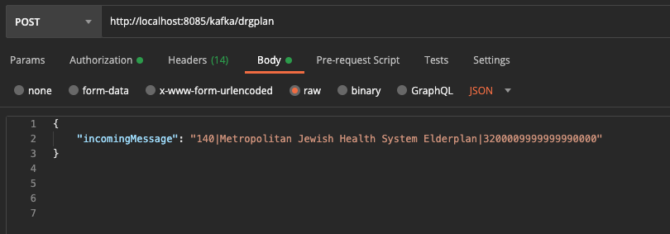

1. REST SERVICE :
   1. Maintains a set of Topic files in the kafka.env file

* Once the Service comes in it validates the application name in the URL (http://localhost:8085/mckesson) with the list of accepted Topics in the kafka.env file.
* 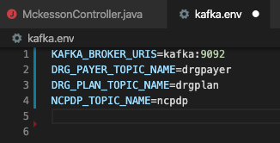

* If it’s one in the list of available topic it sends the message to kafka producer to the appropriate topic
* If it’s NOT in the list it will reject the message (Will not set to Producer)

* ConsumerService

1. CONSUMER
   1. In our Scenario, to keep it simple we can run with only one Consumer listening to all TOPICS, and distinguish the message based on TopicName

                                                              i.      Based on the Topic name the consumer can call the appropriate REST service of the Microservice which takes care of inserting to DB

* + - 1. Topic = DRGPAYER 🡺 call <http://localhost:8089/drgpayer/inserttodrgdatabase>
      2. Topic = DRGPAYER 🡺 call <http://localhost:8089/drgpayer/inserttodrgdatabase>
      3. Topic = NDCPD🡺 call <http://localhost:8089/ncpdp/inserttoncpdbdatabase>
  1. DB – MySQL ( currently, will decide later)
* ProcessService ( separated out from consumer)
* DataService
  + DB – Postgres ( currently, will decide later)